**Assignment1: Design Book ticket web page**

Design the ‘book ticket’ web page of supplied ‘Joy Trip’ application. Here is the sample screen shot of same:

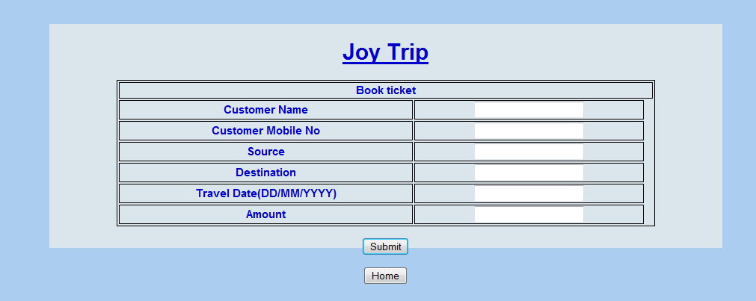

While designing this page, take care of following requirements:

1. Align the Header to center of page
2. Use HTML Form for receiving input from user
3. Structure form inside HTML table
4. Use div tag to define logical sections
5. Use CSS classes/Ids for color, font, position and padding

**Assignment2:Design View & book schedule web page**

Design the ‘View schedule’ web page of supplied ‘Joy Trip’ application. Here is the sample screen shot of same:

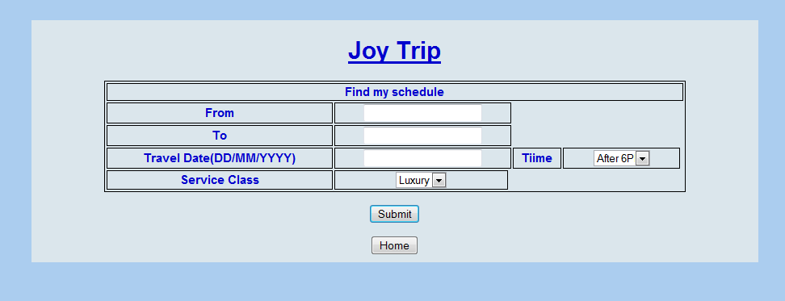

While designing this page, take care of following requirements:

1. Align the Header to center of page
2. Use HTML Form for receiving input from user
3. Structure form inside HTML table
4. Use div tag to define logical sections
5. Use CSS classes/Ids for color, font, position and padding
6. The time section must have following options:
   1. After 6PM
   2. Before 6PM
   3. Any
7. The service class must have following options:
   1. Luxury
   2. Deluxe
   3. Any

**Assignment3:Design View detailed schedule web page**

Design the ‘View detailed schedule’ web page of supplied ‘Joy Trip’ application. Here is the sample screen shot of same:

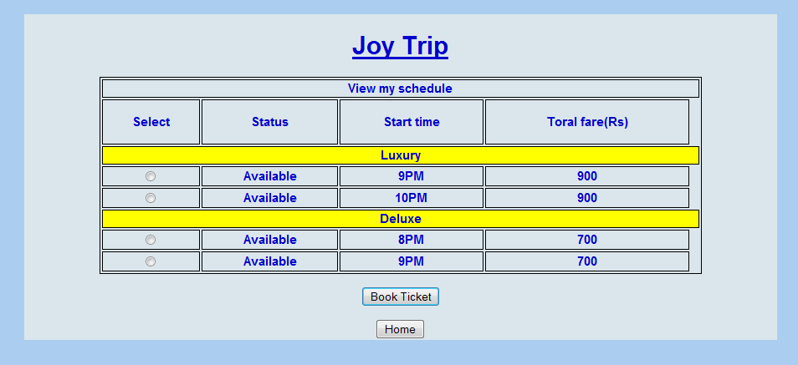

While designing this page, take care of following requirements:

1. Align the Header to center of page
2. Use HTML Form for receiving input from user
3. Structure form inside HTML table
4. Use div tag to define logical sections
5. Use CSS classes/Ids for color, font, position and padding